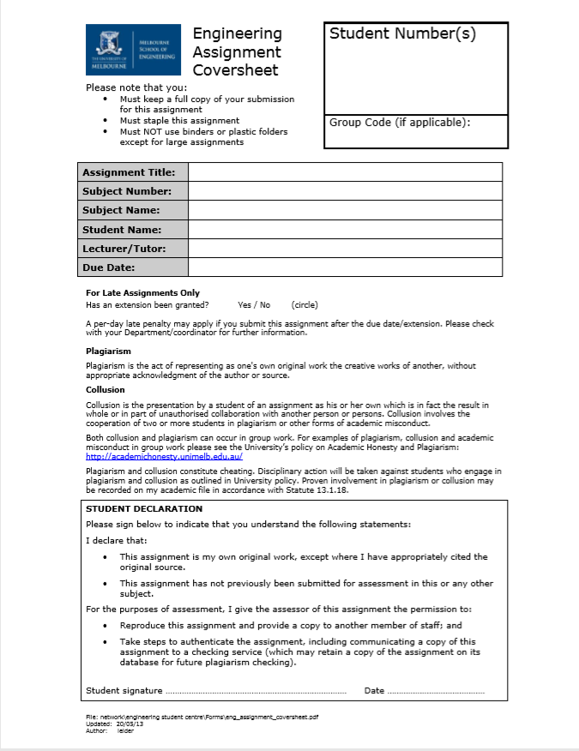

31/08/2020

Charlynn Miller & Dr. Libo Liu

James La Fontaine

Business Analysis Case

ISYS10001

Foundations of Information Systems

1079860

**BUSINESS PROFILE: ING GROUP**

ING Group is a global financial institution of Dutch origin who have a powerful presence in Europe, with their self-proclaimed purpose being to “empower people to stay a step ahead in life and in business”. ING Bank (Australia) is the 5th largest bank in Australia according to their publicly available information on their website, where they also claim to be Australia’s Most Recommended Bank. They are strong competitors in the broad Retail Banking and Wholesale Banking markets as evidenced by their labelling as a ‘systemically important financial institution’ by the Financial Stability Board. They are also present on the EURO STOXX 50; a stock index of European stocks which is made up of ‘fifty of the largest and most liquid stocks’. According to their own published figures, they boasted over 39 million retail customers as of the end of June this year, with 13.5 million considered primary customers. They also boasted over 56,000 employees by the end of 2019. ING are aiming to provide ‘frictionless banking’ and free consumers from restrictions that could hinder their ability to pursue their passions and the things that give their life meaning. This is evidenced by their new brand direction – ‘do your thing’ – which is “about people being free to live the life they want to live, knowing that they will make their world a little better for it”. ING are essentially trying to provide straightforward, sustainable and transparent banking for all their customers to differentiate themselves from other banking institutions. ING’s Wholesale Banking covers over 40 countries worldwide and provides their clients with “one global cross-border experience that is seamless and efficient”. They strive to be a ‘trusted financial partner’ of their customers in this particular market to whom they offer ‘data-driven insights’, ‘sector knowledge’, and ‘customised, integrated solutions’. In Retail Markets, ING offer a full range of banking products and services - covering payments, savings, investments, mortgages and consumer loans. For their corporate clients and financial institution customers, ING provide specialised lending, tailored corporate finance, debt and equity market solutions. They also offer working capital, payments, cash management, trade and treasury services to “help corporates achieve their business goals”. Customers which may make use of ING Group’s aforementioned products and services range from everyday consumers all the way through to corporate clients and financial institutions with any type of banking needs. Moreover, customers who are looking for a bank with exemplary customer experience, innovation and sustainability will likely be interested in doing their banking with ING group.

**PORTER’S FIVE FORCES MODEL ANALYSIS: ING GROUP**

**Bargaining Power of Customers**

Banking is relatively straightforward for most customers to comprehend and thus they do not require special expertise or information to understand the product and services they are receiving. While there are secondary areas (i.e. customer service) a bank can look to stand out in to differentiate themselves from competitors, the main services they provide are all relatively similar. Furthermore, customers have around 50 banks to choose from in Australia alone. ING must be especially careful when it comes to keeping their Wholesale Banking customers as these clients provide a high source of revenue for the bank. It has also become extremely easy to switch banks since the Australian government banking reforms that were introduced back in 2012. Therefore, ING Group must deal with a strong force in relation to the bargaining power of customers in Australia.

**Threat of Substitutes**

ING Group must consider the threat from non-banking institutions that provide similar services such as insurances, mutual funds, alternative payment methods and loans. While these institutions cannot provide all the same services as ING, they can cover a large range of the market when they are all considered and often offer better deals then consumers would otherwise find with traditional banks. Therefore, there is a strong force in relation to the threat of substitutes in a certain portion of the market ING group operates within.

**Bargaining Power of Suppliers**

The large corporations who lend money to ING Group and provide the largest deposits and revenue can be considered major suppliers of the bank. Large amounts of capital can be considered a differentiated product which can not be provided by just any company, and therefore the number of suppliers available to ING Group is not substantial. Therefore, the bargaining power of suppliers can be considered a strong force that ING Group must deal with.

**Threat of New Entrants**

There is a huge amount of capital required to enter the banking industry and reach a level where you can begin to compete with a bank of ING Group’s reputation and capital. Furthermore, unless a bank can provide significantly better interest rates and pricing for consumers (which again would require a significant amount of capital or a new, innovative strategy), then a new bank will have to take the time to build up its reputation through secondary areas such as customer service or technological innovations for example. There is also a lot of legislation surrounding banking that a new company would have to deal with that may discourage new entrants from entering the market. Therefore, there is a weak force in relation to the threat of new entrants.

**Rivalry Among Existing Competitors**

Competition is fierce in the banking markets in both Australia and worldwide. ING Group has to compete with the strength of the 4 big banks in Australia (Commonwealth Bank, Westpac, ANZ, and NAB) and additionally with the many competitors back in Europe and across the globe. These banks are always trying to come out with new innovations and methods of retaining their current customers and obtaining new customers. Therefore, the rivalry among existing competitors is a strong force.

**PORTER’S FOUR COMPETITIVE STRATEGIES: ING GROUP**

The competitive strategy that ING group utilises is a broad market product differentiation strategy with a focus on their customer service, innovation and sustainability. ING Group operates in several areas of the Retail Banking and Wholesale Banking markets with the many services they provide mentioned in the business profile. Therefore, ING Group must adopt a broad market competitive strategy as opposed to a narrow market competitive strategy. Furthermore, ING Group themselves state that “customer experience is what differentiates [them] and [they’re] continuously innovating to improve it” and in relation to sustainability, “[they] facilitate and finance society’s shift to a low-carbon future and pioneer innovative forms of finance to support a better world”. Sustainalytics (a sustainability rating company) rank ING Group as one of the leaders in the banks industry group, and ING Group additionally have an ‘A’ rating in MSCI’s ratings universe. ING Group’s focus on improvement and excellence in these areas clearly demonstrate their product differentiation strategy, especially when considering the wide range of services and products they provide which would make cost leadership an unrealistic strategy due to the nature of banking (i.e. the main services banks provide to most customers are one-dimensional across the market and so pricing is similar). ING Group recognises that there is little to differentiate one bank’s products from another’s and so they strive to create a ‘superior customer experience’ through the use of their ‘advanced data capabilities’ to assist them in understanding their customers and their customer’s needs. They are also aiming to “think beyond traditional banking to develop new services and business models.” Overall, they want their customers everywhere to have the ‘same empowering ING experience’ that will create and maintain a strong brand reputation and encourage their current customers to stick with them and also encourage new customers to start banking with them over other banks due to the aforementioned differentiating factors.

**CRITICAL INFORMATION SYSTEM: ING GROUP**

An Executive Information System will be critical to the success of ING Group as it will enable them to more easily apply their competitive strategy. One of the groups of users of this system are the senior managers of ING Group who access the information pertaining to their customers and revenue projections and can use it to make decisions which meet the competitive strategy of ING Group. At the lowest level, a bank employee working with customers collects data relating to that customer that, after going through the information system, will become useful information when compiled with the data of other customers and will eventually make its way to the executives. The financial analysts working at the bank will also be analysing data relating to ING Group’s profits and form future predictions and create reports that the executives will easily be able to digest and use to gauge the success of new business models and practices, which will allow them to judge how well they are executing their competitive strategy.

Overall, the Executive Information System will facilitate access to the necessary information through easy-to-use user interfaces and heavy processing of data. This information will cover ING Group’s demographics, their customer’s needs and opinions, projections and risk analysis for the future relating to new methods and business models, and ways to run the business in a sustainable and yet profitable manner. This information will be pivotal in allowing ING Group executives to easily make informed decisions. These informed decisions will consequently assist ING Group in achieving their goals of better understanding their customers, continuing to provide quality customer experience, innovating beyond traditional banking, and maintaining sustainable business practices which all tie into their competitive strategy of broad market product differentiation.

*Information sourced from:*

* [ing.com.au](https://www.ing.com.au/)
* [ing.com](http://www.ing.com/About-us/Profile)
* [finance.yahoo.com](https://finance.yahoo.com/)
* [en.wikipedia.org](https://en.wikipedia.org/)
* [fsb.org](https://www.fsb.org/)
* [sustainalytics.com](https://www.sustainalytics.com/)